**What is the Web?**

Have you ever wondered what images will appear in the heads of future generations when it comes to the era in which we live now? It is likely that the 21st century will spark associations with the advent of the **Internet** and the **World Wide Web**. Their creation caused major changes not only in the military and science structures but also in the lives of ordinary people, giving us opportunities that previously could only be imagined.

You so often hear phrases like "The World Wide Web has engulfed our planet", that the definition of the Web is naturally pre-assumed and taken for granted. But really, what is this Web and why is it so global?

The **World Wide Web** is a collection of information resources scattered around the world and linked together by reference. Sometimes this term is shortened to **WWW**, **W3** or simply **Web**.

The Web is also sometimes ironically called Wild Wild Web by analogy with the movie title Wild Wild West: come to think of it, the resemblance is undeniable.

A unit of hypertext data on the W3 is called a **web page**. A web page may contain text, media files, graphics and links to other pages.

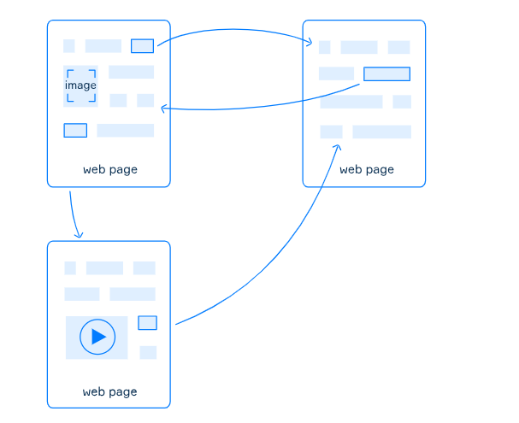

A group of Web pages that share a common content theme, design and links to each other is called a **website**. Special programs — **browsers**—are used to download and browse these websites. Most popular browsers: Firefox, Chrome, Edge, Safari.

Often when you visit sites, you can see "www" in the address bar of the browser:



This prefix indicates that the address of the website belongs to the Internet space of the World Wide Web and is not mandatory.

**The history of the Web**

The World Wide Web was created at the European Organization for Nuclear Energy (CERN). The development of the internal computer network was carried out by the scientist Tim Berners-Lee. In 1989, he was the first to suggest the idea of an information management system that used links to consolidate documents across the network. He and his colleagues created a prototype project and released it for presentation. The first few years of the web pages were purely text-based until the first NCSA Mosaic graphics browser was introduced in 1993. The event allowed the World Wide Web to transform itself from scientific research into a media outlet.

Initially, the Internet only allowed users to search and read information. This period is referred to as **Web 1.0** (~1991-1999) to provide a general presentation of the ever-changing Internet environment.

Soon people were able to interact with each other and share their content. This period is unofficially called **Web 2.0** (~1999-2007).

The development of the World Wide Web continues to this day and we will be able to see what changes **Web 3.0** (~2007- ...) will bring. Currently, Web 3.0 aims to improve content analysis and provide faster and more relevant search results using artificial intelligence.

**Internet vs WWW**

Most people use the terms "Internet" and "WWW" interchangeably, but in fact, these are two separate notions. The **Internet** is a global computer network, i.e., a technical infrastructure that connects millions of computers around the world. While W3 is used to distribute data that contains links to other data, the Internet connects computers to each other to provide access to the information.

It is worth noting that the W3 is just a part of all information that the internet provides access to. Also, there are services such as E-Mail, telephony, FTP, SSH, and other data transfer protocols that are not parts of the Web.

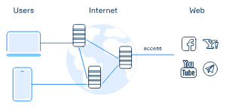**Conclusion**

Simply put, the WWW is a way of obtaining information over the Internet, yet the Internet is also used to access information that is not a part of the Web. Hypertext documents - web pages are the units of the WWW. They may include different content and are usually joined by a shared topic and links to websites. Specific programs called browsers can download websites, so we can explore them.  
Now you understand that the World Wide Web and the Internet actually mean different things. More importantly, now you can demonstrate your knowledge and explain this difference to your friends.

Here is the correct order of the **WWW development stages** from top to bottom:

1. ✅ **People can only search and read information posted on the Internet** *(Web 1.0)*
2. ✅ **People can communicate with each other or share their content** *(Web 2.0)*
3. ✅ **Improved content analysis and accelerated time of its finding** *(Web 3.0 – Semantic Web)*

**Explanation:**

* **Web 1.0**: Read-only web — static content.
* **Web 2.0**: Read-write web — user interaction and content sharing.
* **Web 3.0**: Intelligent web — semantic understanding, AI, and better data linking.

Is there a difference between the Internet and the World Wide Web? If so, what is it?

The Internet connects computers around the world, and the Web disseminates information.

Explanation:

The Internet is the global network of interconnected computers and devices.

The World Wide Web (Web) is a service that runs on the Internet, used to disseminate (spread) information through websites and web pages.

Explain the relationship between the Web and the Internet.

The Web is a way of obtaining information over the Internet

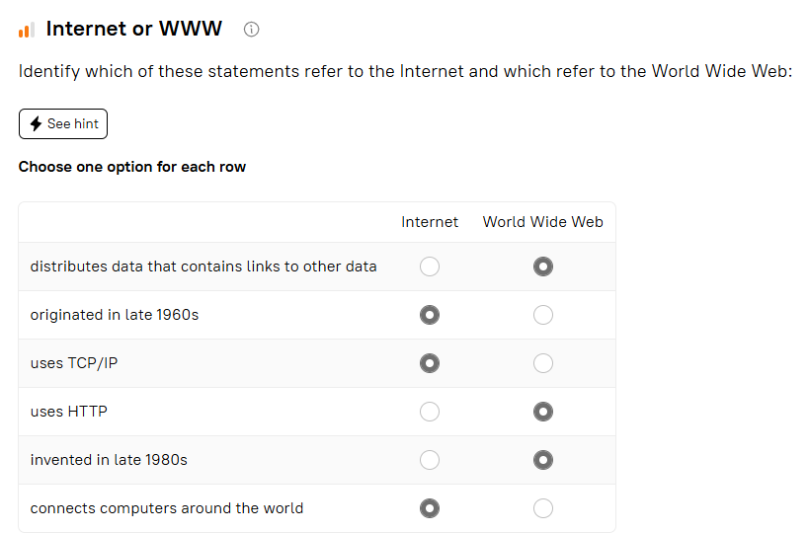

Select the various shortened forms used for the term "World Wide Web" from the list:

WWW

W3

Web

Explanation:

WWW – Common abbreviation for World Wide Web.

W3 – A shorthand used by organizations like W3C (World Wide Web Consortium).

Web – The most casual and widely used term.